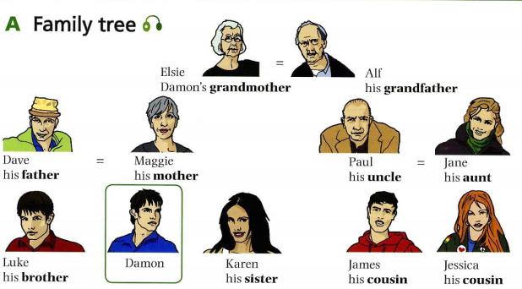
FAMILY AND JOBS

VOCABULARY A. Complete the sentences about Damon’s family with words form the box.
nephew grandparents son relatives daughter husband wife niece sister-in-law married
Male Female
husband ____________
____________ sister
____________ daughter
uncle ___________
nephew ___________
____________ sister-in-law
grandfather ___________
cousin ___________
- All the people here are Damon’s ___________________________.
- Karen is Maggie’s ____________________________.
- Maggie is Dave’s ___________________________.
- Elsie and Alf are ___________________________.
- Jessica is Dave’s ___________________________.
- Damon is Jane’s ___________________________.
- Elsi and Alf are Luke’s ____________________________.
- Damon is Dave’s and Maggie’s _________________________.
- Paul is Jane’s ____________________________.
- Jane is Maggie’s ___________________________.
B. Complete the table

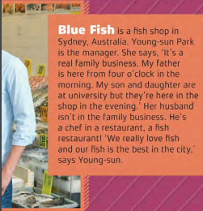



- 2.

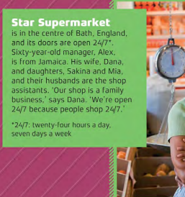

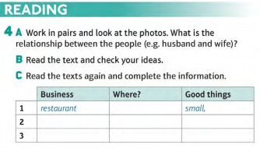
3.
3.

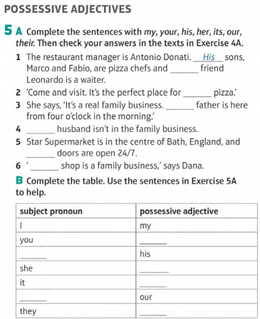
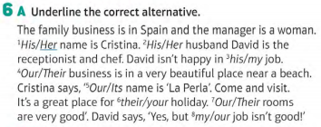

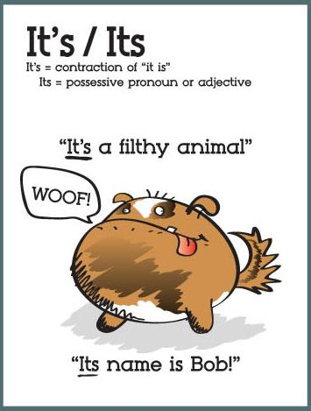

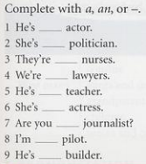
7. Read the texts again. How many jobs can you find? 8.
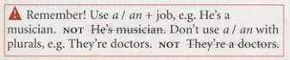
Do you know any more jobs in English?

9. A. Read and write the names in the pictures
Caroline Matthew Rosanna Orlando Petra Lionel Paula Scott Danielle
Carolyn is the mother. She's the cook. She's in the kitchen.
Her husband is Matthew. He's the manager. He's in the office.
Rosanna is their daughter. She's the porter. She's at the entrance.
Orlando is their son. He's the waiter. He's in the hotel restaurant.
Petra is his wife. She's the waitress. She's in the hotel restaurant.
Lionel is her brother. He's the barman. He's in the bar.
Paula is her sister. She's the gardener. She's in the garden.
Her parents are Scott and Danielle. They're on holiday! They're in the swimming pool.

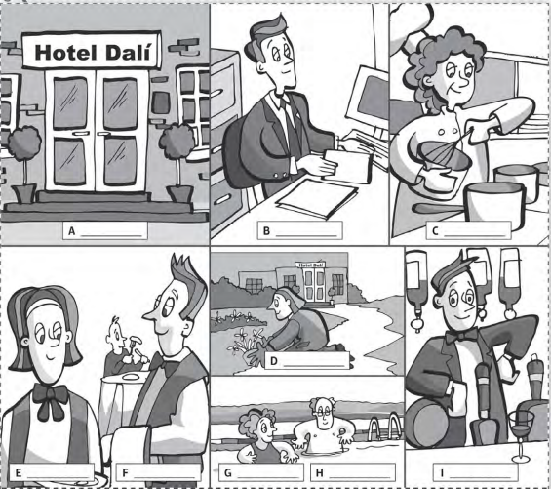

B. Match the names to the jobs
1. cook ___ 2. manager ___ 3. porter ___ 4. waiter ___ 5. waitress ___ 6. barman ___ 7. gardener ___

ANSWERS
Vocabulary
- 1. relatives 2. daughter 3. wife 4. married 5. niece 6. nephew 7. grandparents 8. son 9. husband 10. sister-in-law
- Husband/wife, brother/sister, son/daughter, uncle/aunt, nephew/niece, brother-in-law/sister-in-law, grandfather/grandmother, cousin/cousin (no change)
Reading
4 A.
- Father and sons
- Wife and husband, mother and father, sister and brother, daughter and son
- Husband and wife
C.
 | business | where | good things
1 | restaurant | Washington D.C.  USA | small, friendly, great food
2 | fish shop | Sydney, Australia | family business, best fish in the city
3 | supermarket | Bath, England | Open 24/7

5.
subject pronoun | Possessive adjective
I | my
you | your
he | his
she | her
it | its
we | our
they | their
- 1. His / their 2. your 3. My 4. My 5.its 6. Our B.

6. A. 1. Her 2. Her 3. his 4. Their 5. Its 6. your 7. Our. 8. My
7. manager, chef, waiter, shop assistant
8. 1. an 2. a 3. – 4. – 5. a 6. an 7. a 8. a 9. A
9. A. Rosanna B. Matthew C. Carolyn D. Paula E. Petra F. Orlando G. Danielle H. Scott I. Lionel
B. 1. C 2. B 3. A 4. F 5. E 6. I 7. D

